
Sec 2-6 Systems of Equations
Applications Name:

- The Turbo Taxi Service charges a flat rate of $5 and then $0.40 per mile. The Express Taxi Company charges a flat rate of $2 and then $0.75 per mile.

- Write an equation that describes the cost, c, of each taxi cab in terms of miles, m, driven.

Turbo Taxi Service: c =


Express Taxi Co: c =

- When do the two taxi cabs charge the same amount?

- Describe when the Express Taxi Company charges more than Turbo Taxi Services.

- Theresa was taking her 2 grandchildren to the zoo. Theresa purchased 1 adult ticket for herself and 2 children’s tickets for $18.20. A family of 5 were also visiting the zoo. The family purchased 2 adult and 3 children’s tickets for $30.90.
  - Write an equation that describes each purchase:


Theresa:

Family:

  - Solve the system to determine how much an adult’s ticket costs for the zoo.

M. Winking Unit 2-6 page 39

- A sales person that worked at a cell phone store recorded the following information about the number of Android phones and iPhones that he sold for the day:

- He sold a total of 24 smartphones that were either an iPhone or an Android phone.
- The iPhones that he sold were all priced at $200 and the all of the Android phones were priced at $150. He sold a total of value of $4150 in smartphones.

  - Write an equation that describes each piece of information. Let ‘P’ represent the number of iPhones and ‘A’ represent the number of Android Phones.


Total Number:

Total Sales:

  - Using the system of equations determine the number of each type of phone that was sold.

- A local school sold 230 tickets for their performance of Hamlet. They sold a combination of regular tickets and student tickets. The regular tickets sold for $8 each and the student tickets sold for $5. That night they collected $1522 in ticket sales.

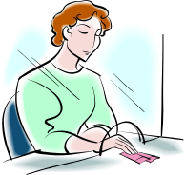
  - Write an equation that describes each piece of information. Let ‘R’ represent the number of regular tickets and ‘S’ represent the number of Student tickets.

  - Using the system of equations determine the number of each type of ticket that was sold.

M. Winking Unit 2-6 page 40


- At the Hardware store, they sell 6 pound bags of grass seed for $15 and they sell 20 pound bags of grass seed for $40. A landscaping company purchased a total of 14 bags of the grass seed mentioned and paid a total of $435. How many of each type of bag did the company purchase?

- Janice left home at 12:00 pm. She drove to the airport at an average speed of 40 miles per hour. The airport is a distance of 70 miles away from her house. Her husband, Mike, realized she forgot to take her bathroom bag for her trip and left the same house at 12:30 pm to go to the airport. He average 60 miles per hour on the trip.

  - Let ‘y’ represent the distance each person is away from their house and ‘x’ represent the number of hours traveled after 12:00pm. Write an equation describing each person’s distance away from their house.

Janice:

Mike:

  - Graph the system of equations below:
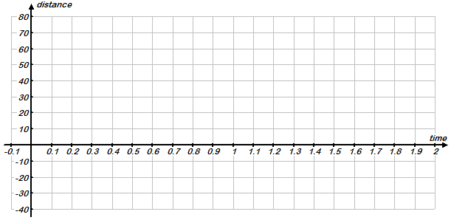

  - Will Mike catch up to Janice before she gets to the airport? If so, at what time would he catch up with her?

  - Approximately what time would each arrive at the airport?

M. Winking Unit 2-6 page 41

- CarStax is a used car dealership. At CarStax they pay their salespeople $550 a week plus $150 for each car they sell. Andy’s Autos is another used car dealership. At Andy’s they pay their salespeople $400 a week plus $180 for each car sold

  - Let ‘y’ represent the amount a sales person earns in a week and ‘x’ represent the number of cars sold each week. Write an equation describing each dealership’s salary for a sales person.

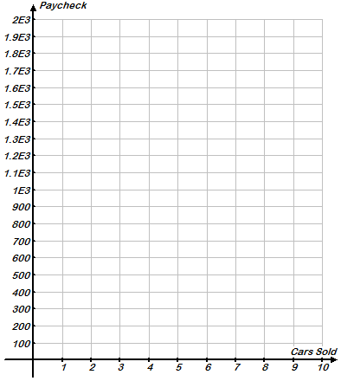
CarStax:

Andy’s Autos:

  - Graph the system of equations below:

  - At what point do the two dealerships pay the salesperson the same amount?

  - Determine when each dealership pays a higher salary.
M. Winking Unit 2-6 page 42

